| **Project – External Document** |  |
| --- | --- |
| COMP6800001  Human and Computer Interaction |
| Even Semester Year 2021/2022 |

* **Project Title**

FArbucks

* **Introduction**

FArbucks is a coffee store website that was founded in December 2021. Its branches are spread all over the world. FArbucks provides several types of coffee and held events.

* **Report / Documentation**

1. Home

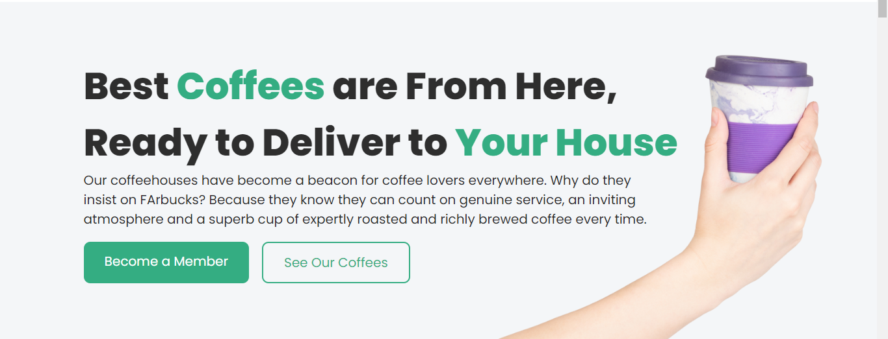

1. Coffee

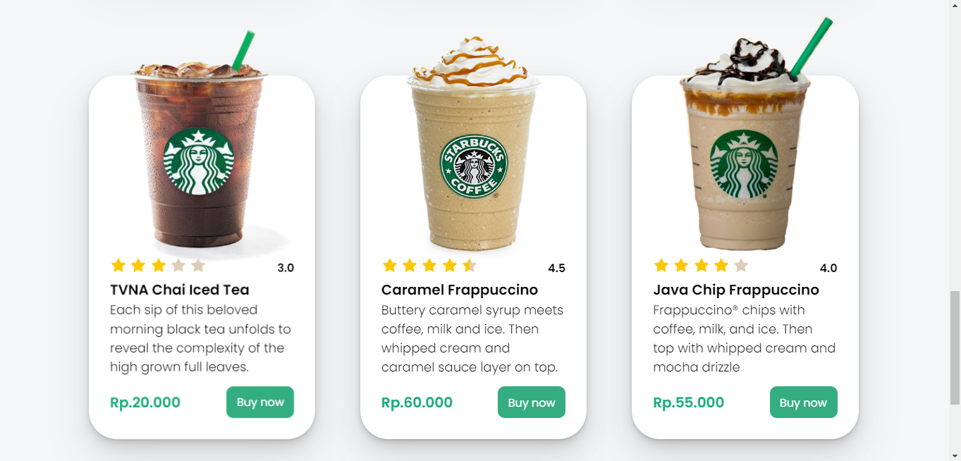

1. Events

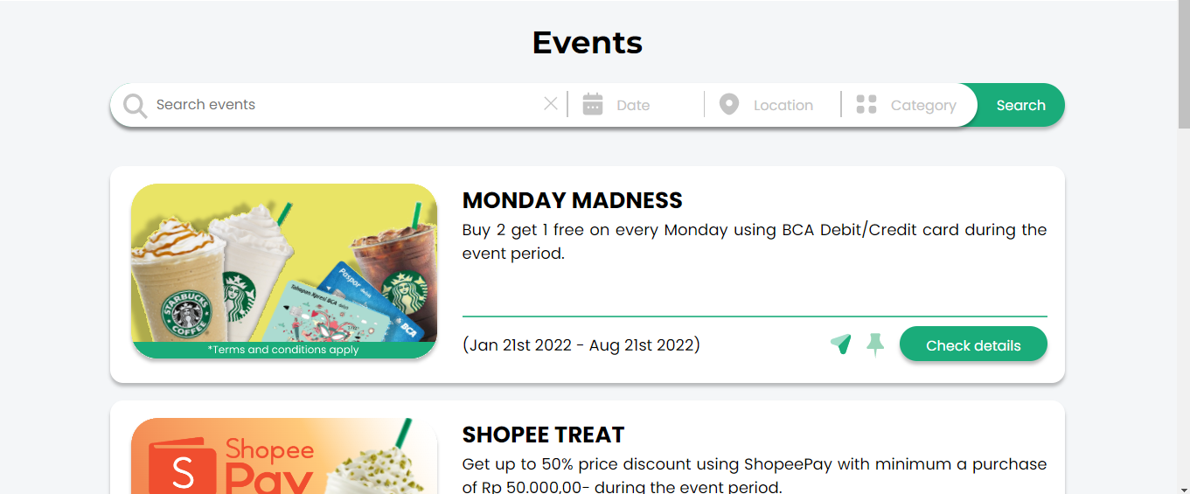

1. About Us

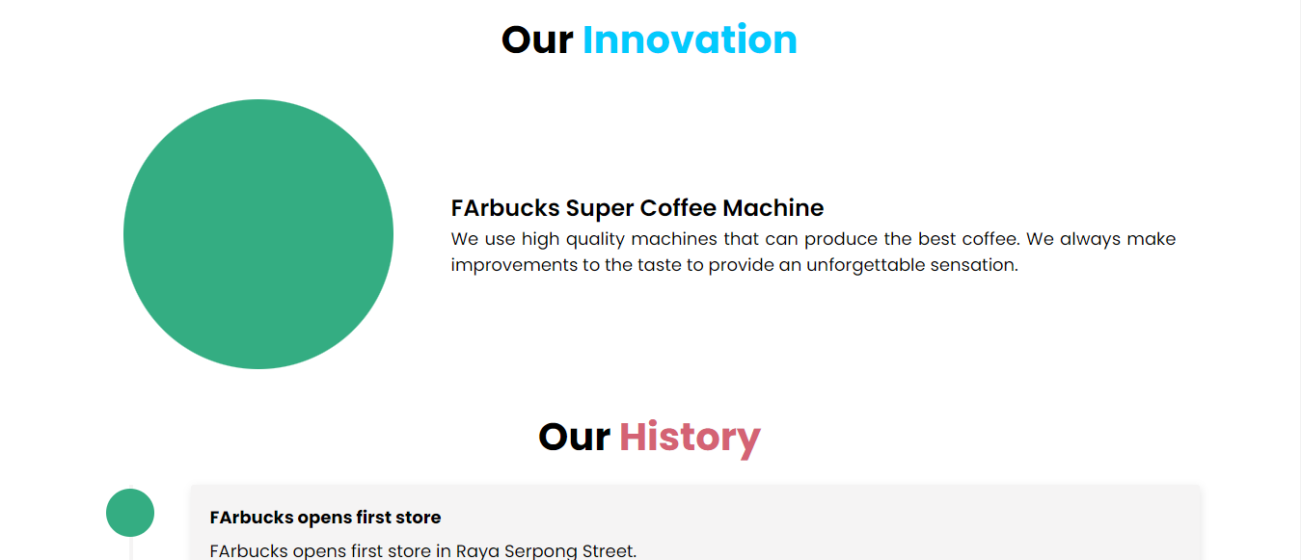

1. Register



* **Hidden Creativities**
* Figma Prototype: Text Field (try click and press space, then enter), form components, card carousel, and accordion
* Pure CSS Responsive Navbar







* Pure CSS Card Carousel

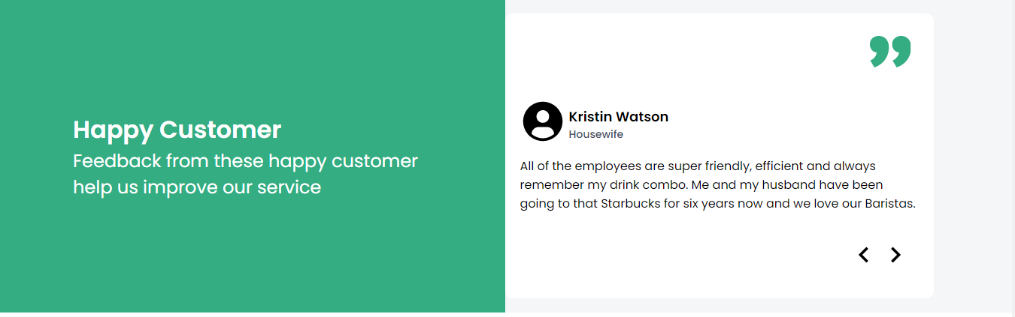

* Pure CSS Modal

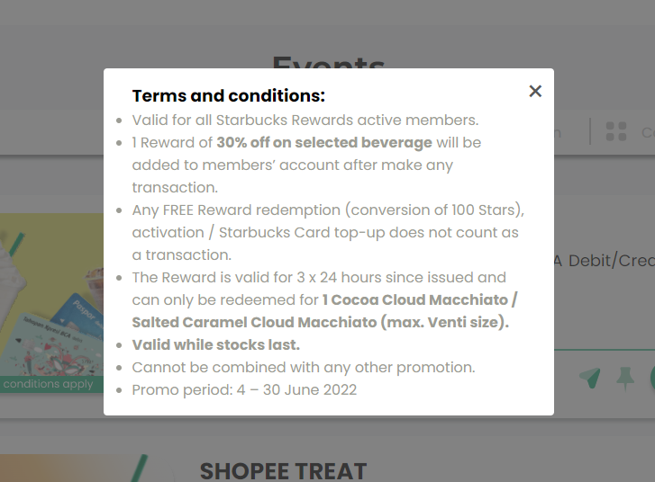

* **Reference**
* Images / Illustration
  + https://icons8.com/photos
  + https://www.kindpng.com/
  + https://www.hiclipart.com/
  + https://www.nicepng.com/
  + https://www.flaticon.com/
  + Vicolo
  + https://icons8.com/photos/photo/i-wish-you-were-the-cream-in-my-coffee--5b4fed908b65880001441ae4
  + https://icons8.com/photos/photo/cookies-and-tea-is-a-great-option-for-evening-treat--5be42be88b658800019138b5
  + https://icons8.com/photos/photo/coffee-is-always-a-great-option--5b43c16c8b6588000165bd36
  + <https://icons8.com/photos/photo/morning-coffee-mess--5b43c1c98b6588000165bd4b>
  + [https://www.google.com/url?sa=i&url=https%3A%2F%2Fwww.bca.co.id%2Fid%2FIndividu%2Fproduk%2Fsimpanan%2FTahapan-Xpresi&psig=AOvVaw0iZ_Pq7OYsRYPRxaYsDukl&ust=1649258331391000&source=images&cd=vfe&ved=0CAoQjRxqFwoTCOi5mpqc_fYCFQAAAAAdAAAAABAn](https://www.bca.co.id/id/Individu/produk/simpanan/Tahapan-Xpresi)
  + [https://www.google.com/url?sa=i&url=https%3A%2F%2Fwww.opsiku.com%2Fmedia%2Ffinance%2Fjenis-kartu-atm-bca%2F&psig=AOvVaw1joxsz7rSjtWsGwEe0PJ3i&ust=1649258526446000&source=images&cd=vfe&ved=0CAoQjRxqFwoTCNCh2_ec_fYCFQAAAAAdAAAAABAi](https://www.opsiku.com/media/finance/jenis-kartu-atm-bca/)
  + <https://gudrilogo.blogspot.com/2021/07/logo-shopee-pay-vector-format-cdr-ai.html>
  + <https://2.bp.blogspot.com/-kOMLbfT51pc/WVpT6ta7cgI/AAAAAAAAB9I/Z7i0Uxrv1EsmyRGa2Ao2I6WI4bOFuH2BQCLcBGAs/w1200-h630-p-k-no-nu/d8e22b3c2f47c4019b6d6bfd1402b728-plastic-bag-free-day-illustration.jpg>
  + <https://1.bp.blogspot.com/-Iq0Ztu117_8/XzNYaM4ABdI/AAAAAAAAHA0/MabT7B02ErIzty8g26JvnC6cPeBZtATNgCLcBGAsYHQ/s1000/logo-ovo.png>
  + https://www.dlf.pt/dfpng/middlepng/421-4212063_starbucks-coffee-press-8-cup-brew-press-bodum.png
* Animated Icons
  + https://lordicon.com/
* Plugin
  + Iconify
* **Group Member**
* 2501959333 – Fico Pangestu
* 2501959301 – Renaldo Furiady

**note**: we use **SVG** to reduce project **size**